Sometimes I’m known to have a good idea. So, sitting at the Moody AFB Thunder Over South Georgia Airshow, talking with the Fire Chief…
It suddenly hit me. We’ve done all this good work about CFR and extraction, but nothing about what happens next. When they pull you from the wreckage and begin stabilization and transport and the Golden Hour.
In 2011, I had a heart attack. So speaking for myself, there’s lots of things a first or even second responder would like or need to know about me. For example, my EKG will be very strange, unless you know I have stents. Certain drugs I’m on will affect the medications used on me. How to convey this information? I thought of MedAlert; but they cost money and being a cheap airline guy I didn’t want to go that way. Then I thought of the military solution; dogtags, wore them for years, even had one in my boot laces.
So, dogtags it is. They make red anodized ones, but there’s a limit on what you can engrave per line and I take enough pills I needed more room.
So, I found these at http://tacticalgear.com/tg-red-medic-alert-dog-tag-kit-red:
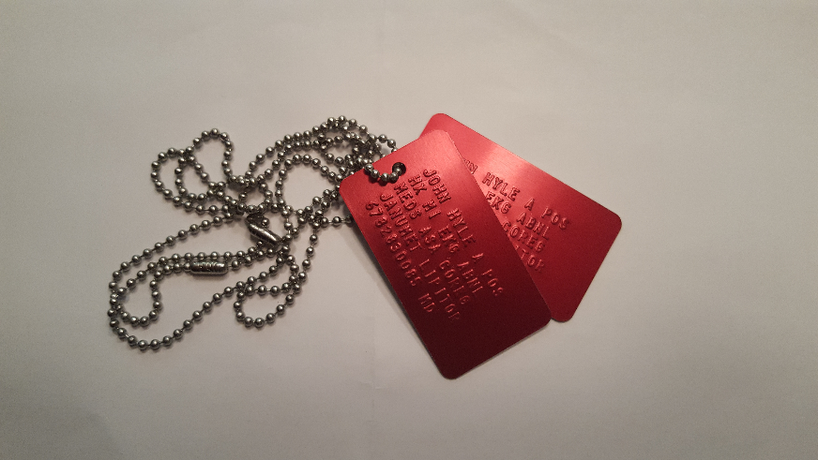
$9.99 at TacticalGear.com and they do the engraving.

Even if there’s nothing wrong with you and there are no allergies to worry about, you should know it takes 15 minutes for a STAT order for blood type and cross match to be completed. That’s once you hit the door to the Emergency Room. 25% of the Golden Trauma Hour gone.
For those of you with something wrong, a complete medical history is not required. But anything concerning clotting, blood pressure, heart rhythm, and any medical issues they should know (like an MI, a renal stent, etc.) you might want to put down there. Below is a close up of mine:
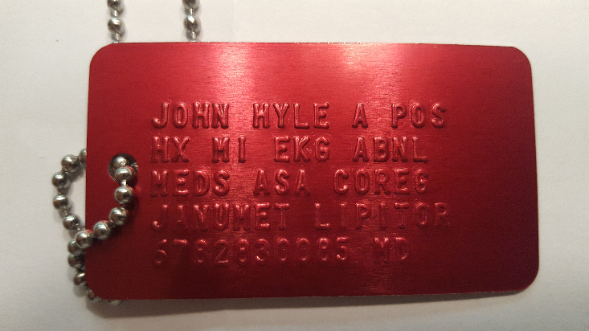
To explain: Name, Blood type, Medical History, Meds, and my In Case of Emergency phone number.

